Project Design Phase-II
Technology Stack (Architecture & Stack)
Date | 12 October 2026
Team ID | 323103282097.aswija@gvpcew.ac.in
Project Name | ServiceNow Employee Raise Issue Portal
Maximum Marks | 4 Marks
Technical Architecture
The diagram below represents the workflow supported by the supplied ServiceNow instance screenshots.
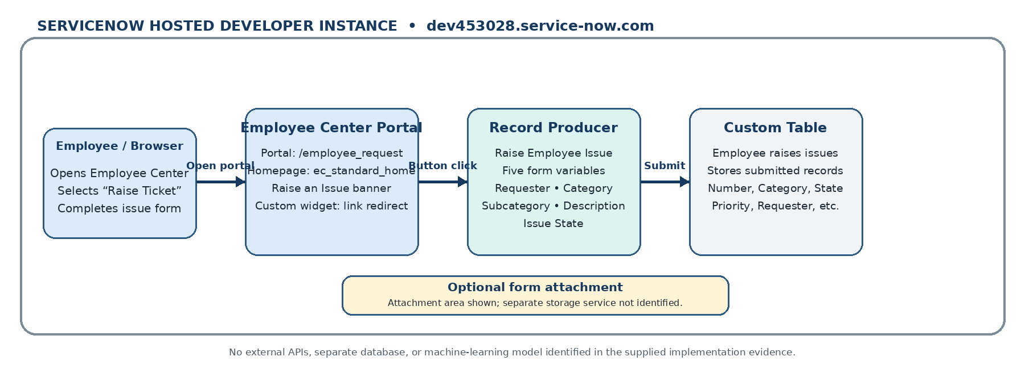
Architecture boundary: ServiceNow-hosted developer instance. No external API, separate database, or machine-learning component is identified in the supplied evidence.

Table-1: Components & Technologies
S.No | Component | Description | Technology
1 | User Interface | Employee-facing Employee Center portal with a Raise an Issue banner and Raise Ticket button. | ServiceNow Employee Center / Service Portal; HTML and CSS in custom widget.
2 | Application Logic-1 | The link redirect widget handles the Raise Ticket click and opens the Raise Employee Issue Record Producer using c.openRecordProducer(). | ServiceNow widget Client Script (JavaScript).
3 | Application Logic-2 | The Raise Employee Issue Record Producer presents five variables: requester name, category, subcategory, short description, and issue state. | ServiceNow Record Producer / Service Catalog variables.
4 | Application Logic-3 | No additional application logic component is confirmed in the provided screenshots. | Not separately identified.
5 | Database | The custom table stores submitted issue records. The list view shows Number, Category, Subcategory, State, Priority, Requester, Assignment Group, and Short description. | ServiceNow custom table: Employee raises issues.
6 | Cloud Database | No separate database service is configured or identified; issue records are stored within the ServiceNow platform. | ServiceNow platform-managed data storage; no external database identified.
7 | File Storage | The issue form includes an attachment area. A separate file-storage service is not shown. | ServiceNow form attachment capability; separate storage service not identified.
8 | External API-1 | No external API integration is shown in the supplied project screenshots. | Not used / not identified.
9 | External API-2 | No second external API integration is shown in the supplied project screenshots. | Not used / not identified.
10 | Machine Learning Model | The demonstrated workflow is a ServiceNow issue-submission portal; no machine-learning model is shown. | Not used.
11 | Infrastructure (Server / Cloud) | The portal and records run in the ServiceNow developer instance. No separate server configuration is shown. | ServiceNow-hosted developer instance / cloud platform.

Table-2: Application Characteristics
S.No | Characteristics | Description | Technology
1 | Open-Source Frameworks | No separate open-source framework is identified in the implementation screenshots. The custom widget uses HTML, CSS, and JavaScript within ServiceNow. | ServiceNow widget framework; HTML, CSS, JavaScript.
2 | Security Implementations | The application runs inside the ServiceNow platform. The supplied evidence does not show custom ACL rules, encryption configuration, firewall settings, or other project-specific security controls. | ServiceNow platform security; custom controls not verified.
3 | Scalable Architecture | The solution uses the hosted ServiceNow platform, a portal widget, a Record Producer, and a custom table. No custom microservices or multi-tier infrastructure are shown. | ServiceNow platform architecture; no custom microservices identified.
4 | Availability | The application is hosted on the ServiceNow developer instance. No project-configured load balancer, replica, or failover setup is evidenced. | ServiceNow-hosted instance; custom availability configuration not identified.
5 | Performance | The demonstrated workflow is a portal-to-Record-Producer submission flow. No project-specific caching, CDN, or throughput/load-test configuration is shown. | Standard ServiceNow portal and record submission; performance tuning not identified.
References
• ServiceNow documentation: https://www.servicenow.com/docs/
• ServiceNow Service Portal documentation: https://www.servicenow.com/docs/bundle/washingtondc-servicenow-platform/page/build/service-portal/concept/service-portal.html
• ServiceNow Record Producer / Service Catalog documentation: https://www.servicenow.com/docs/
• Implementation evidence: user-provided screenshots of the custom table, Raise Employee Issue Record Producer, and link redirect widget.

